**TASKS**

1. Write a program to find GCD/HCF of 2 numbers HCF (highest common factor)

HCF(12,36)=12;

12={1,12,2,6,3,4}

36={1,36,2,18,3,12,4,9,6}

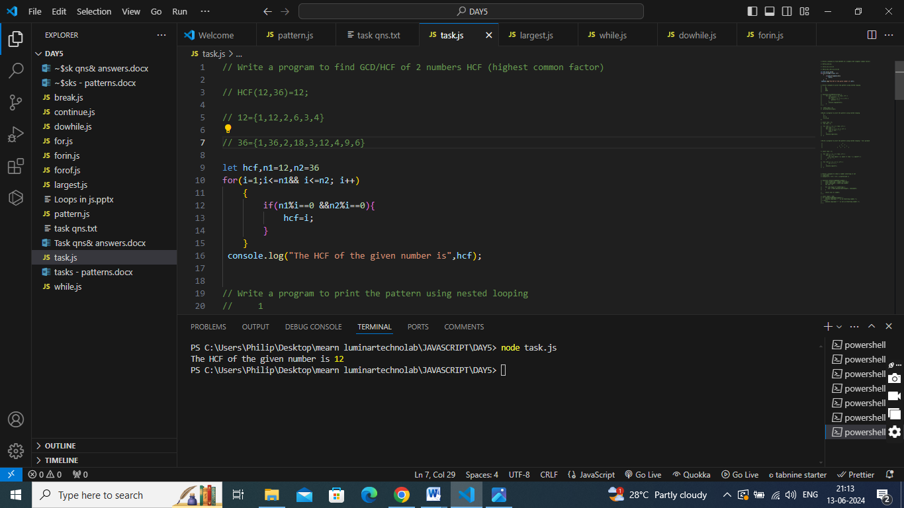

2. Write a program to check a number armstrong or not

input=153;

output=1^3 + 5^3 + 3^3 = 1+125+27=153

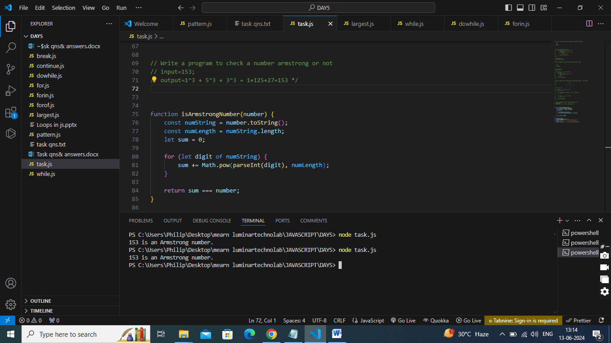

3. Write a program to print the pattern using nested looping

1

22

333

4444

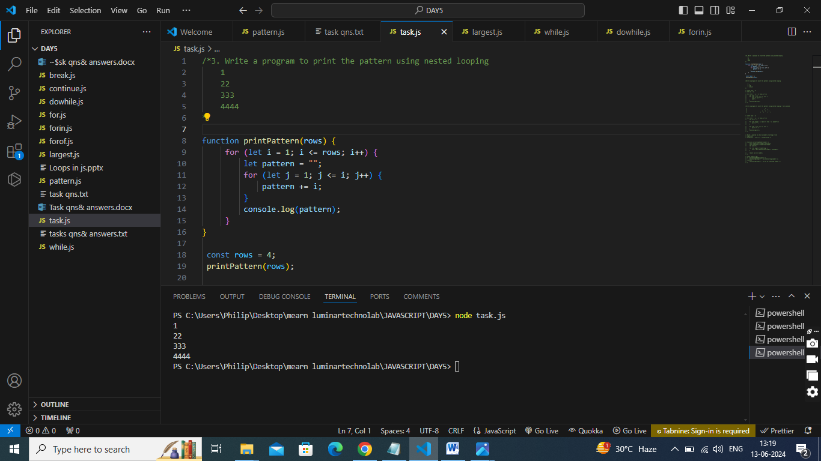

4. Write a program to print the pattern using nested looping - full pyramid.

*

* *

* * *

* * * *

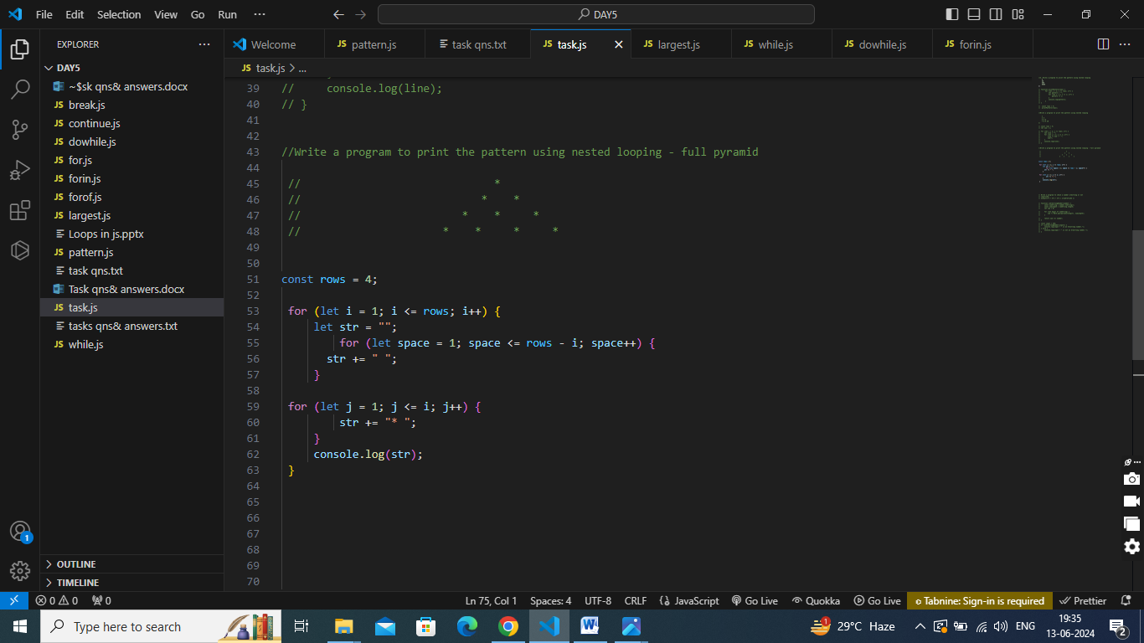

5. Write a program to print the pattern using nested looping

1

2 3

4 5 6

7 8 9 10

